Traide Fair Australia
During a recent trade fair visit (14.04.2025) to XAG Sydney Australia, supported by further online research, the XAG P150 agricultural drone was identified as a promising solution for the removal of invasive plant species. The drone features a payload capacity of up to 70 kg and uses the RevoSpray 4 system to apply herbicides either across wide areas or with pinpoint accuracy. The spraying system delivers fine droplets via adjustable centrifugal nozzles, enabling effective coverage on both sides of plant leaves.
The process is managed using PIX4Dfields, a mapping and control software. First, a drone equipped with a high-resolution camera captures detailed images of the area. In the software, the user manually marks invasive species, protected plants, and obstacles. These inputs train the software to recognize similar vegetation patterns using machine learning. The generated prescription map is then uploaded to the spraying drone, which treats only the marked zones with high precision.
Compared to ground-based mowers like the ROBO MOWER T-90 by NetEvoTech, spraying drones offer several advantages. Mechanical mowing can lead to seed dispersion and is limited in difficult or uneven terrain. Experts advised against the use of mowers in this context and recommended drone application to avoid further spread and ensure better reach. The system is also compatible with drone charging stations from Enovance, which can quickly recharge batteries for continuous operation. The total cost for a two-drone system including software is approximately AUD 50,000.
Sources:
XAG P150 Product Page: https://www.xa.com/en/p150
PIX4Dfields Software Overview: https://www.pix4d.com/product/pix4dfields
RevoSpray 4 Spraying System: https://www.xa.com/en/revospray
ROBO MOWER T-90 Specs (NetEvoTech): https://www.netevotech.com/robo-mower-t90
Enovance Drone Charging: https://enovance.com.au/

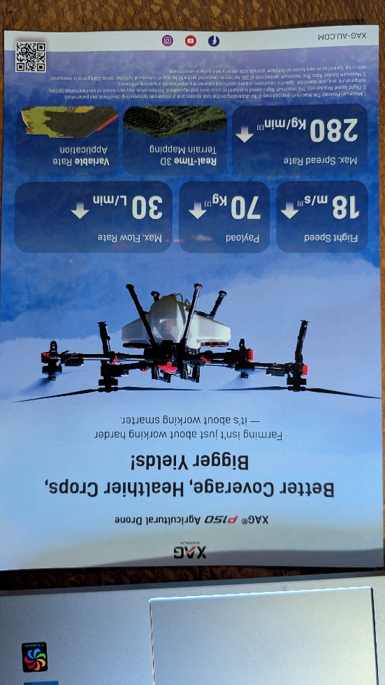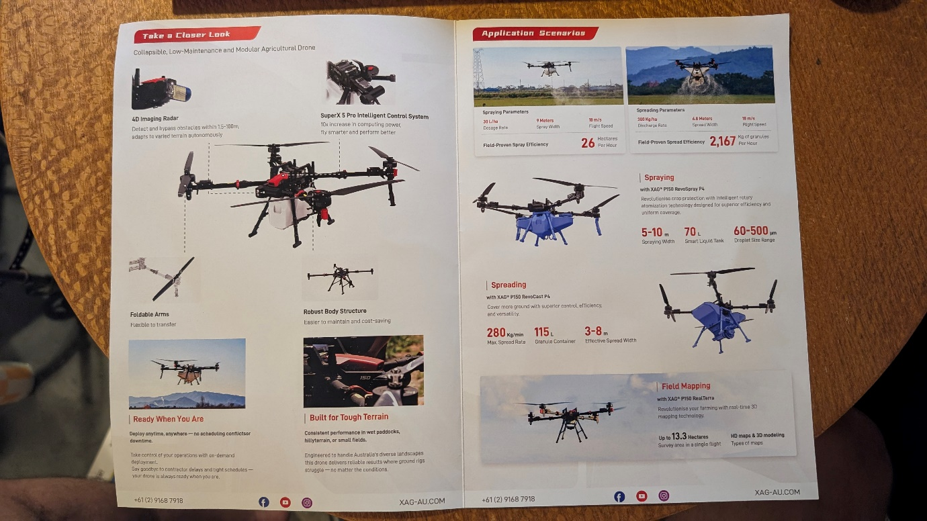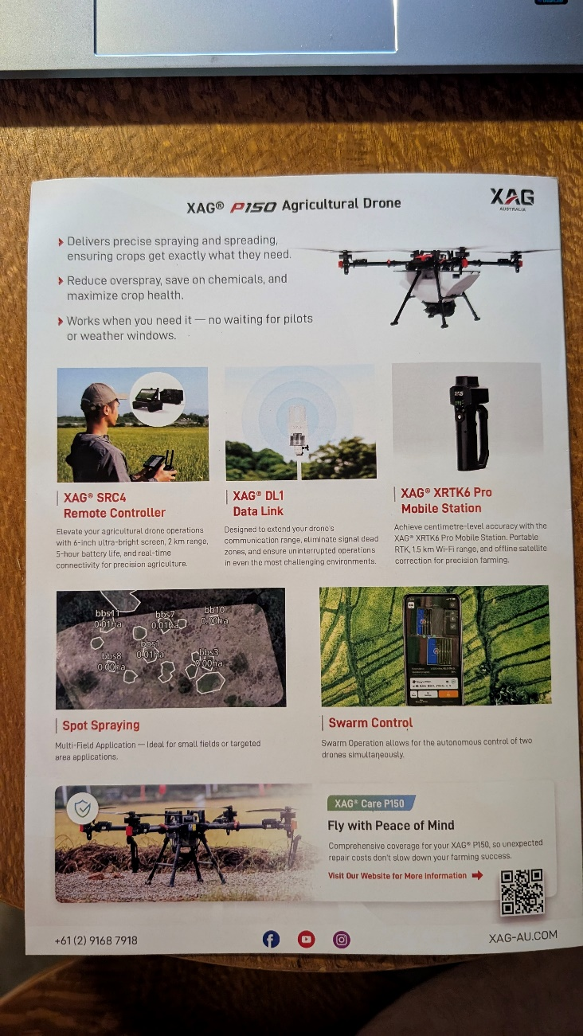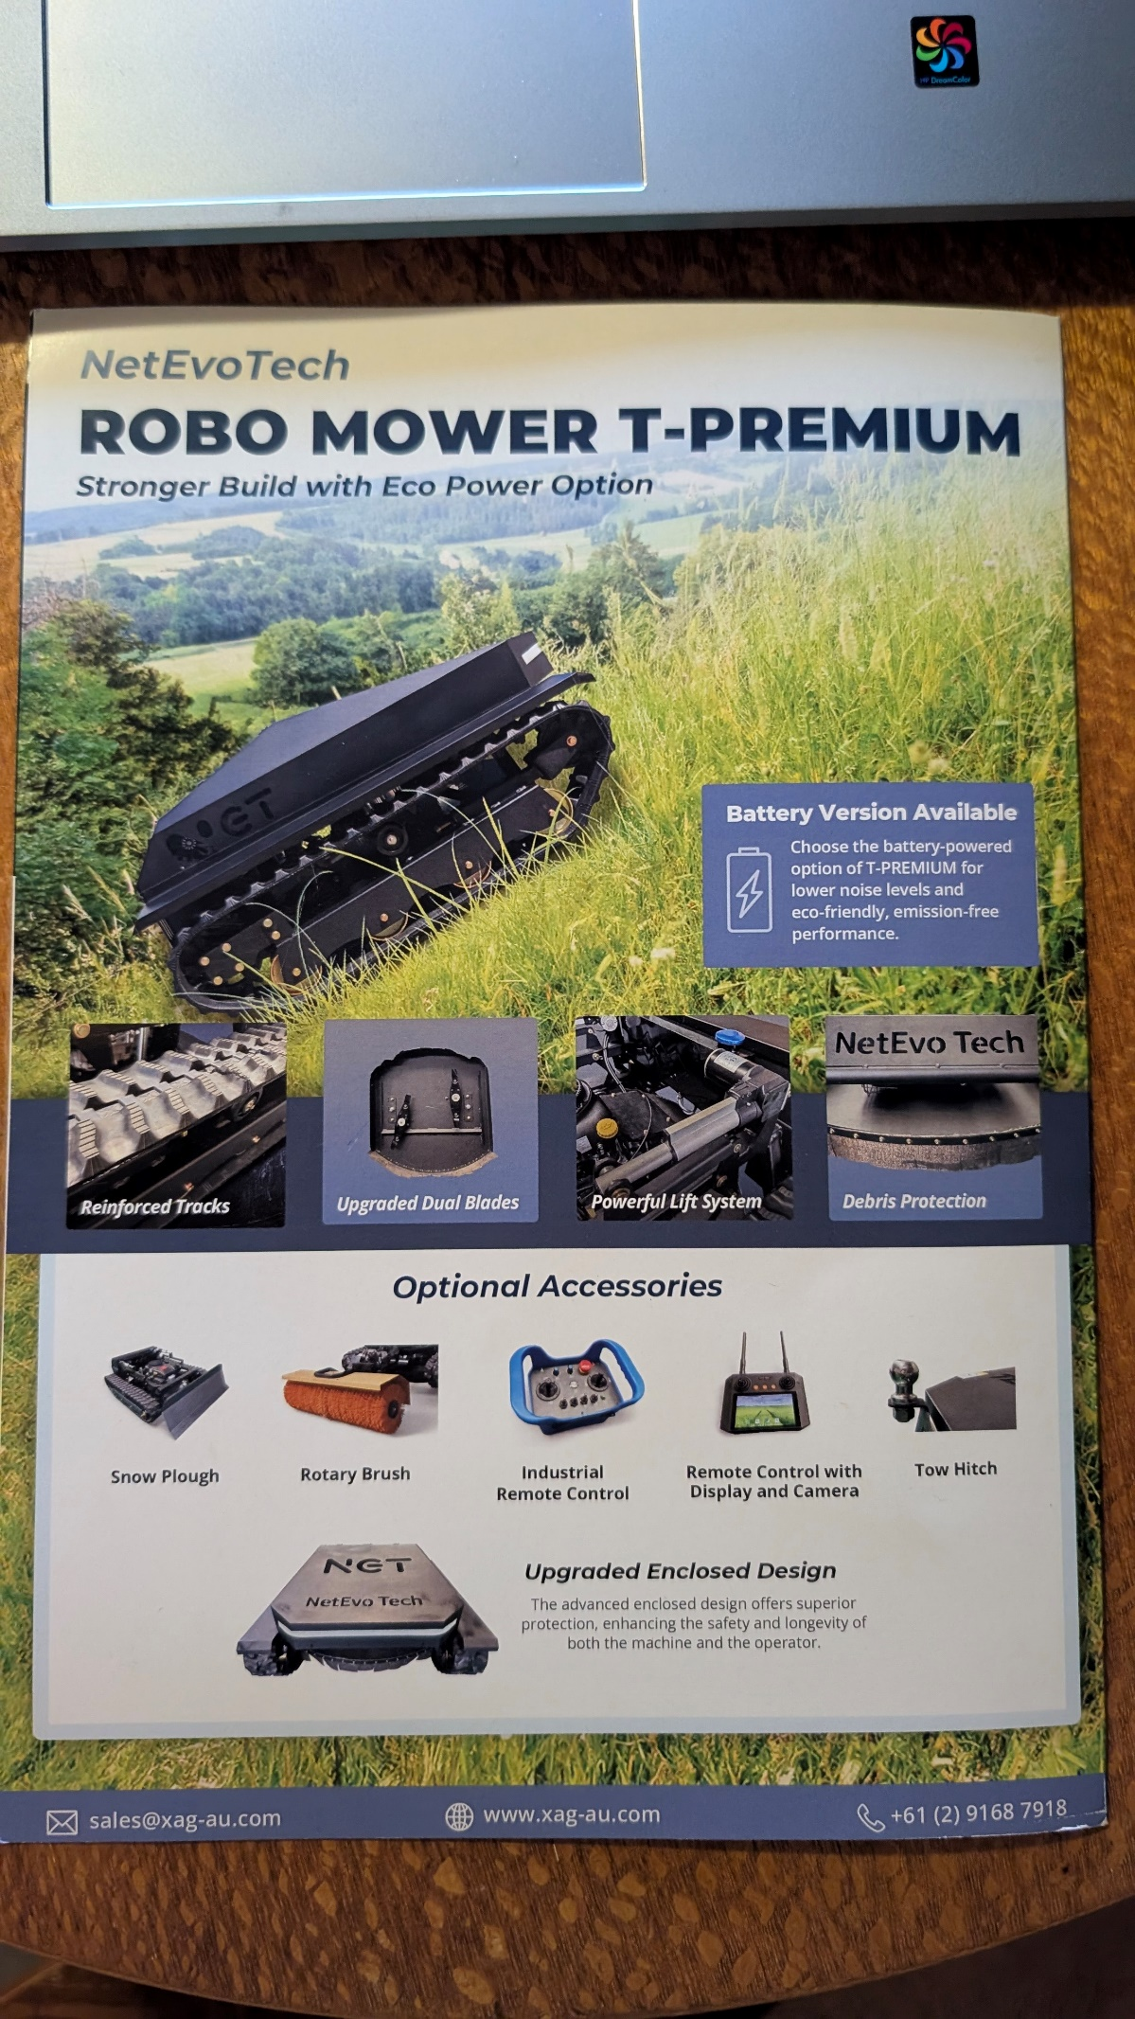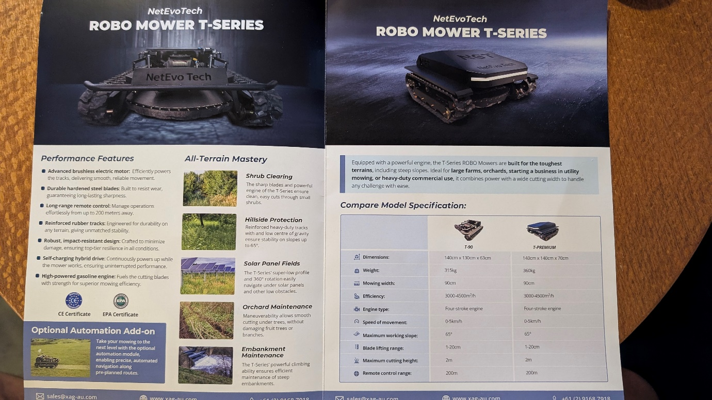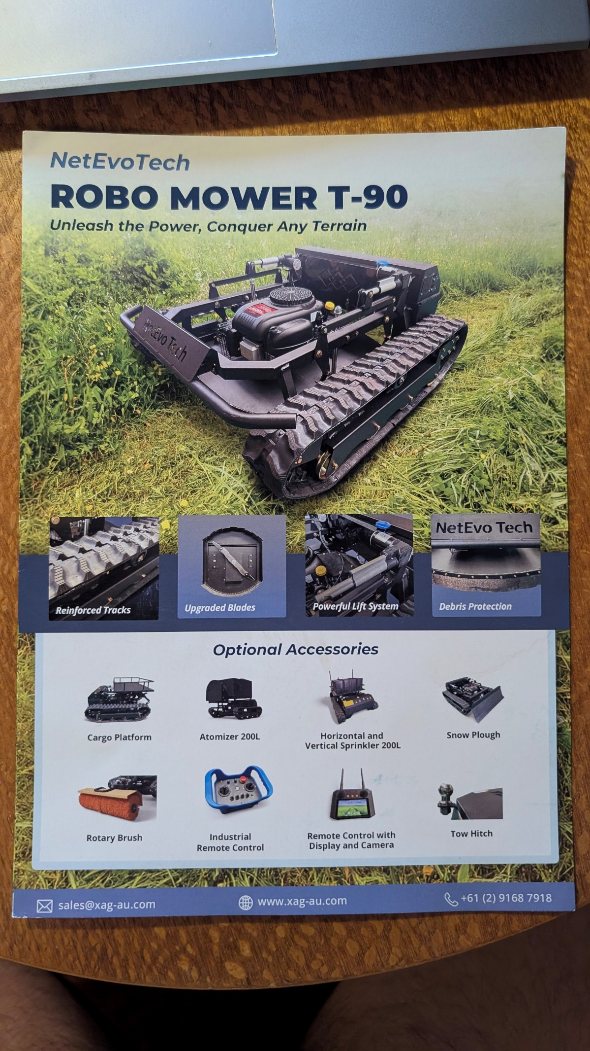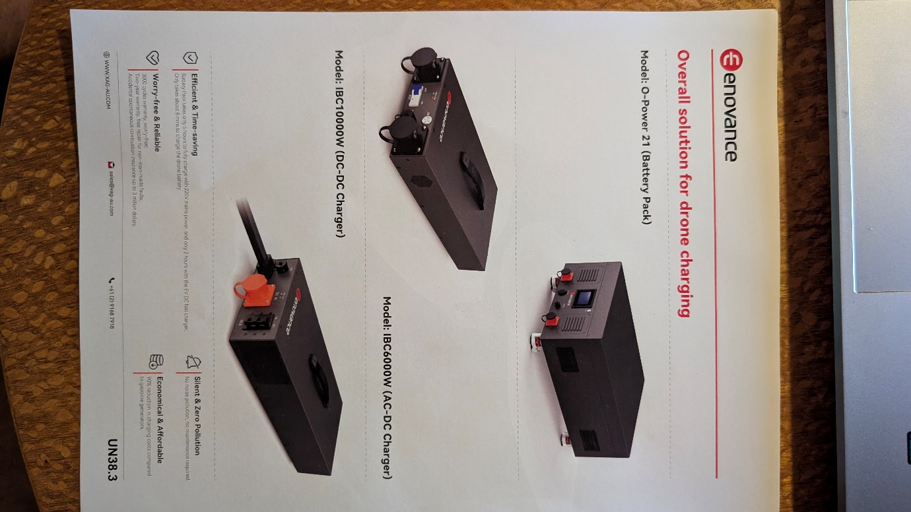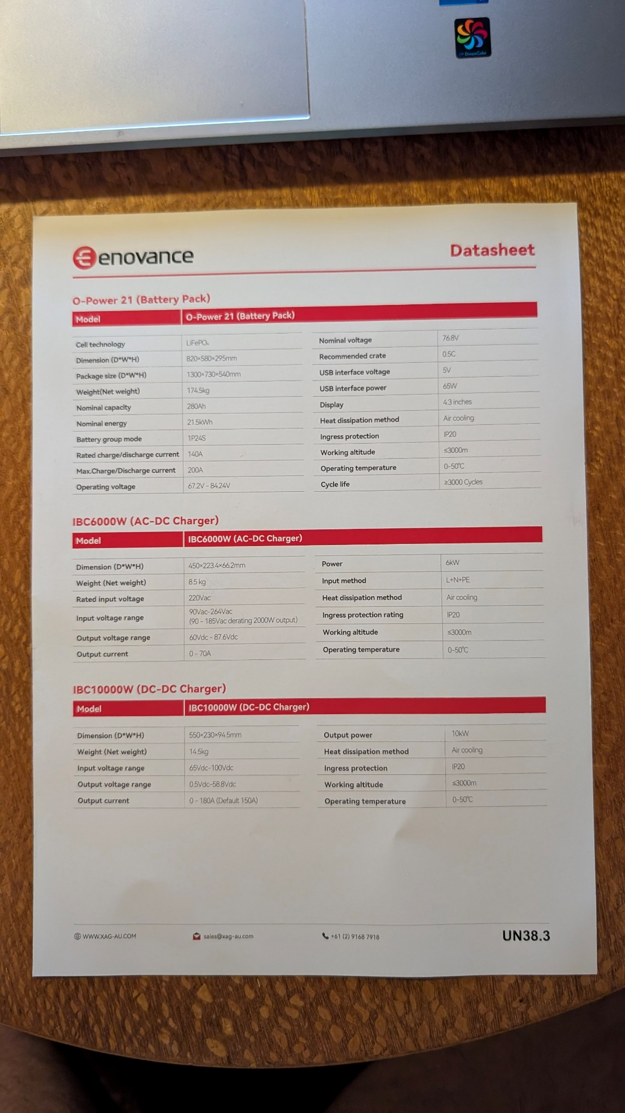
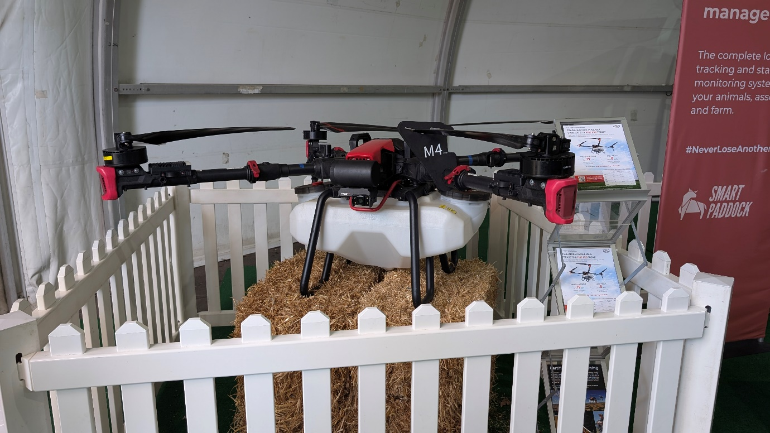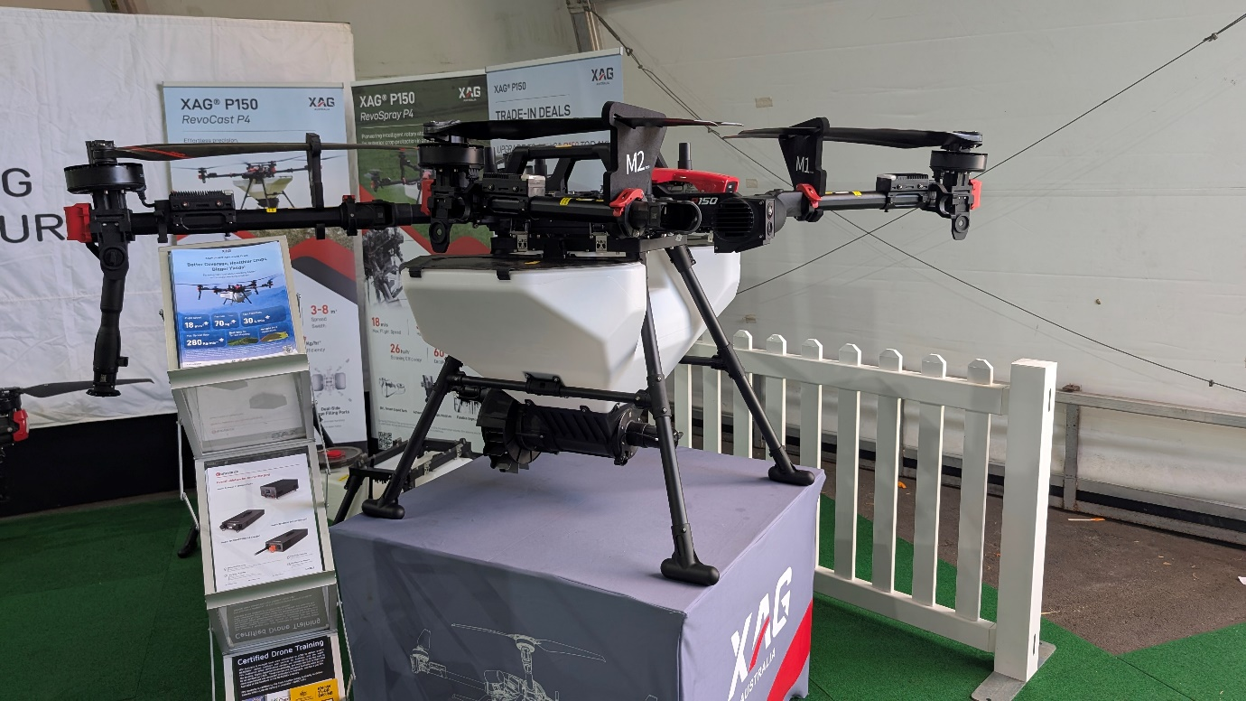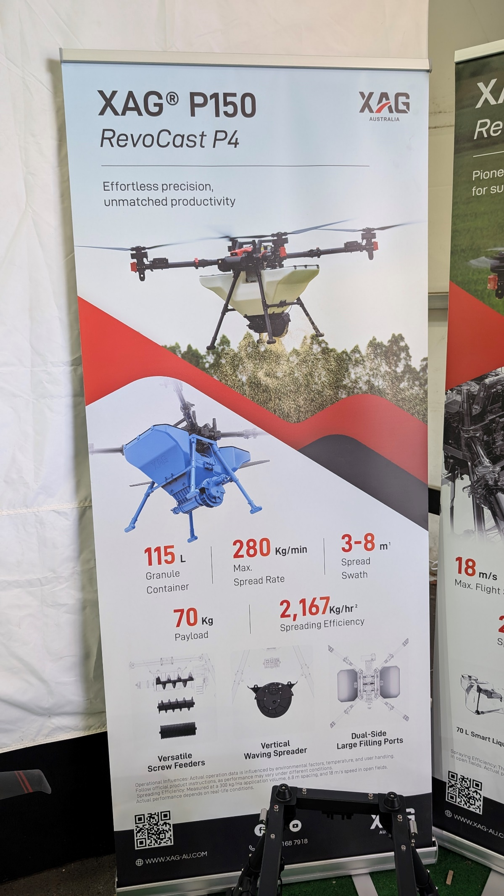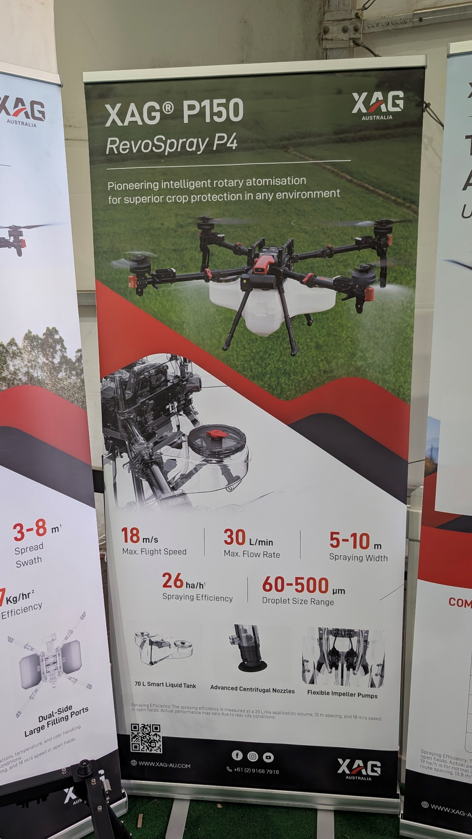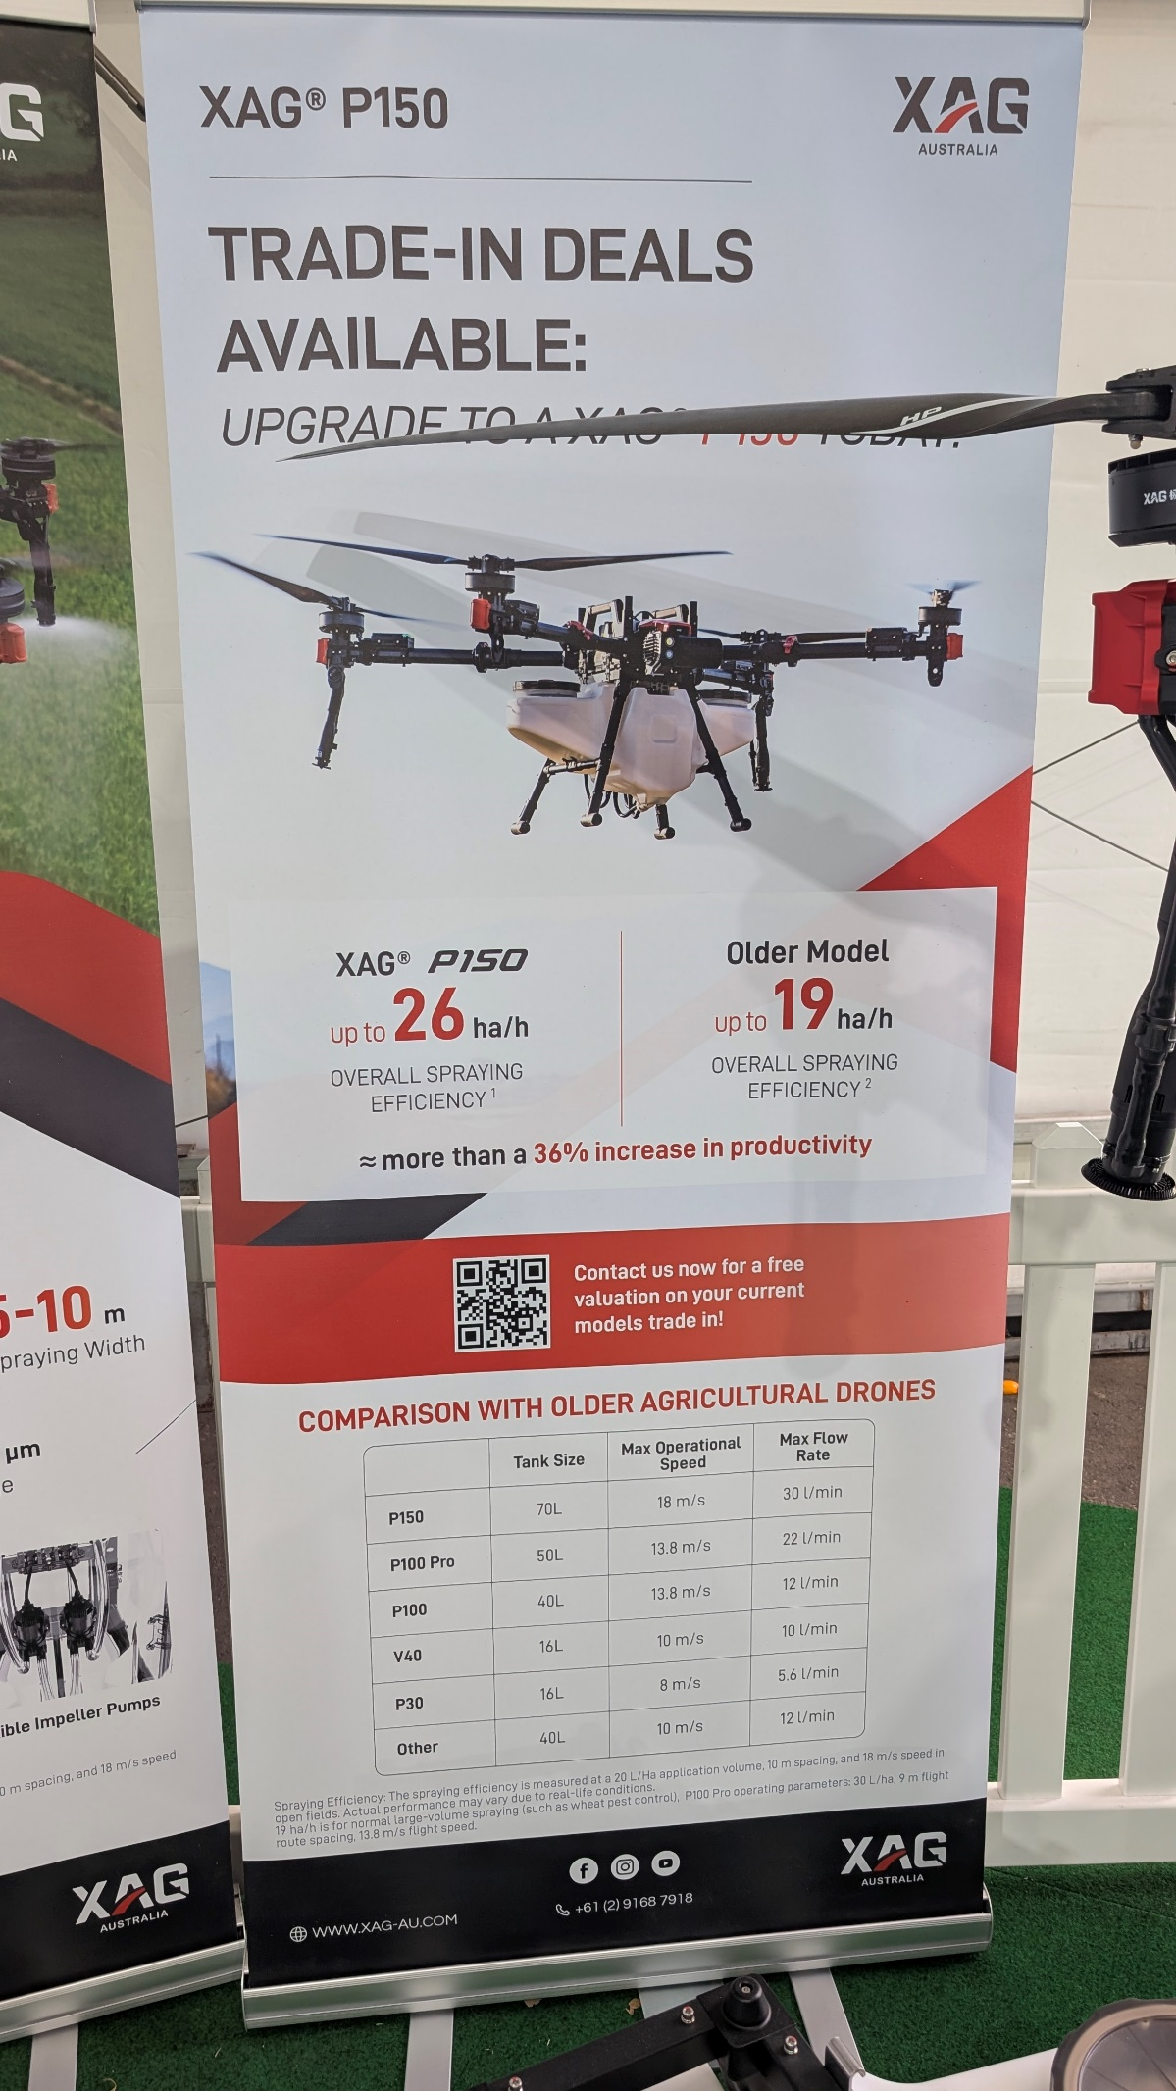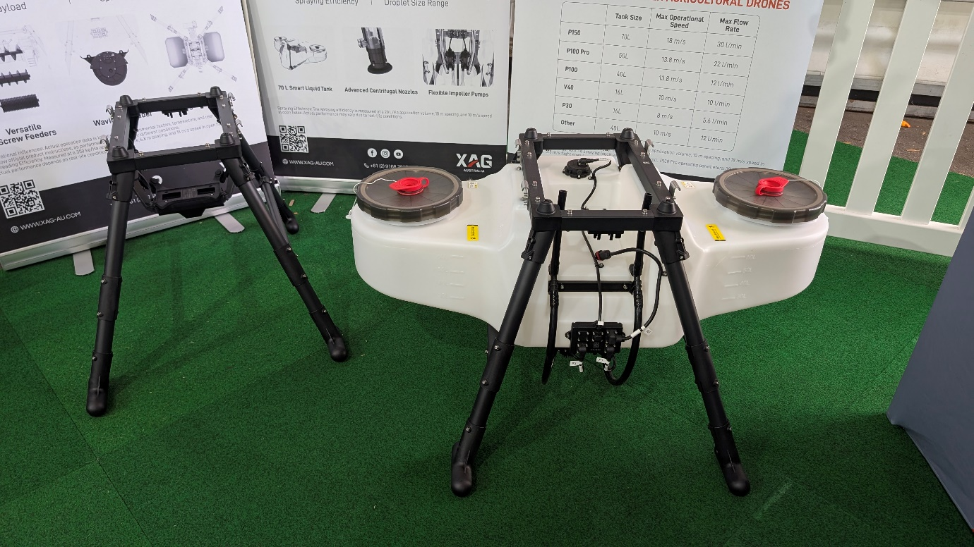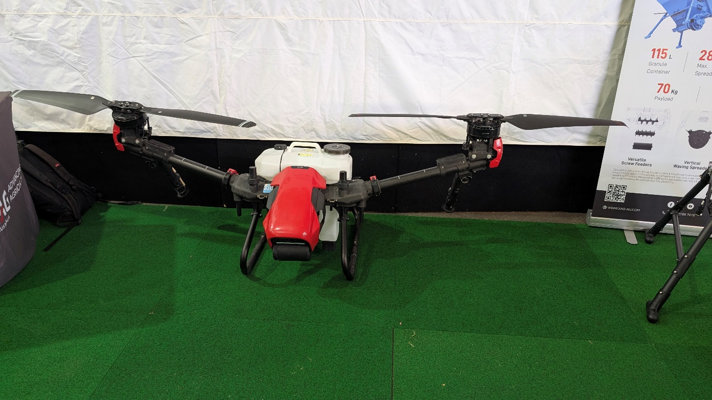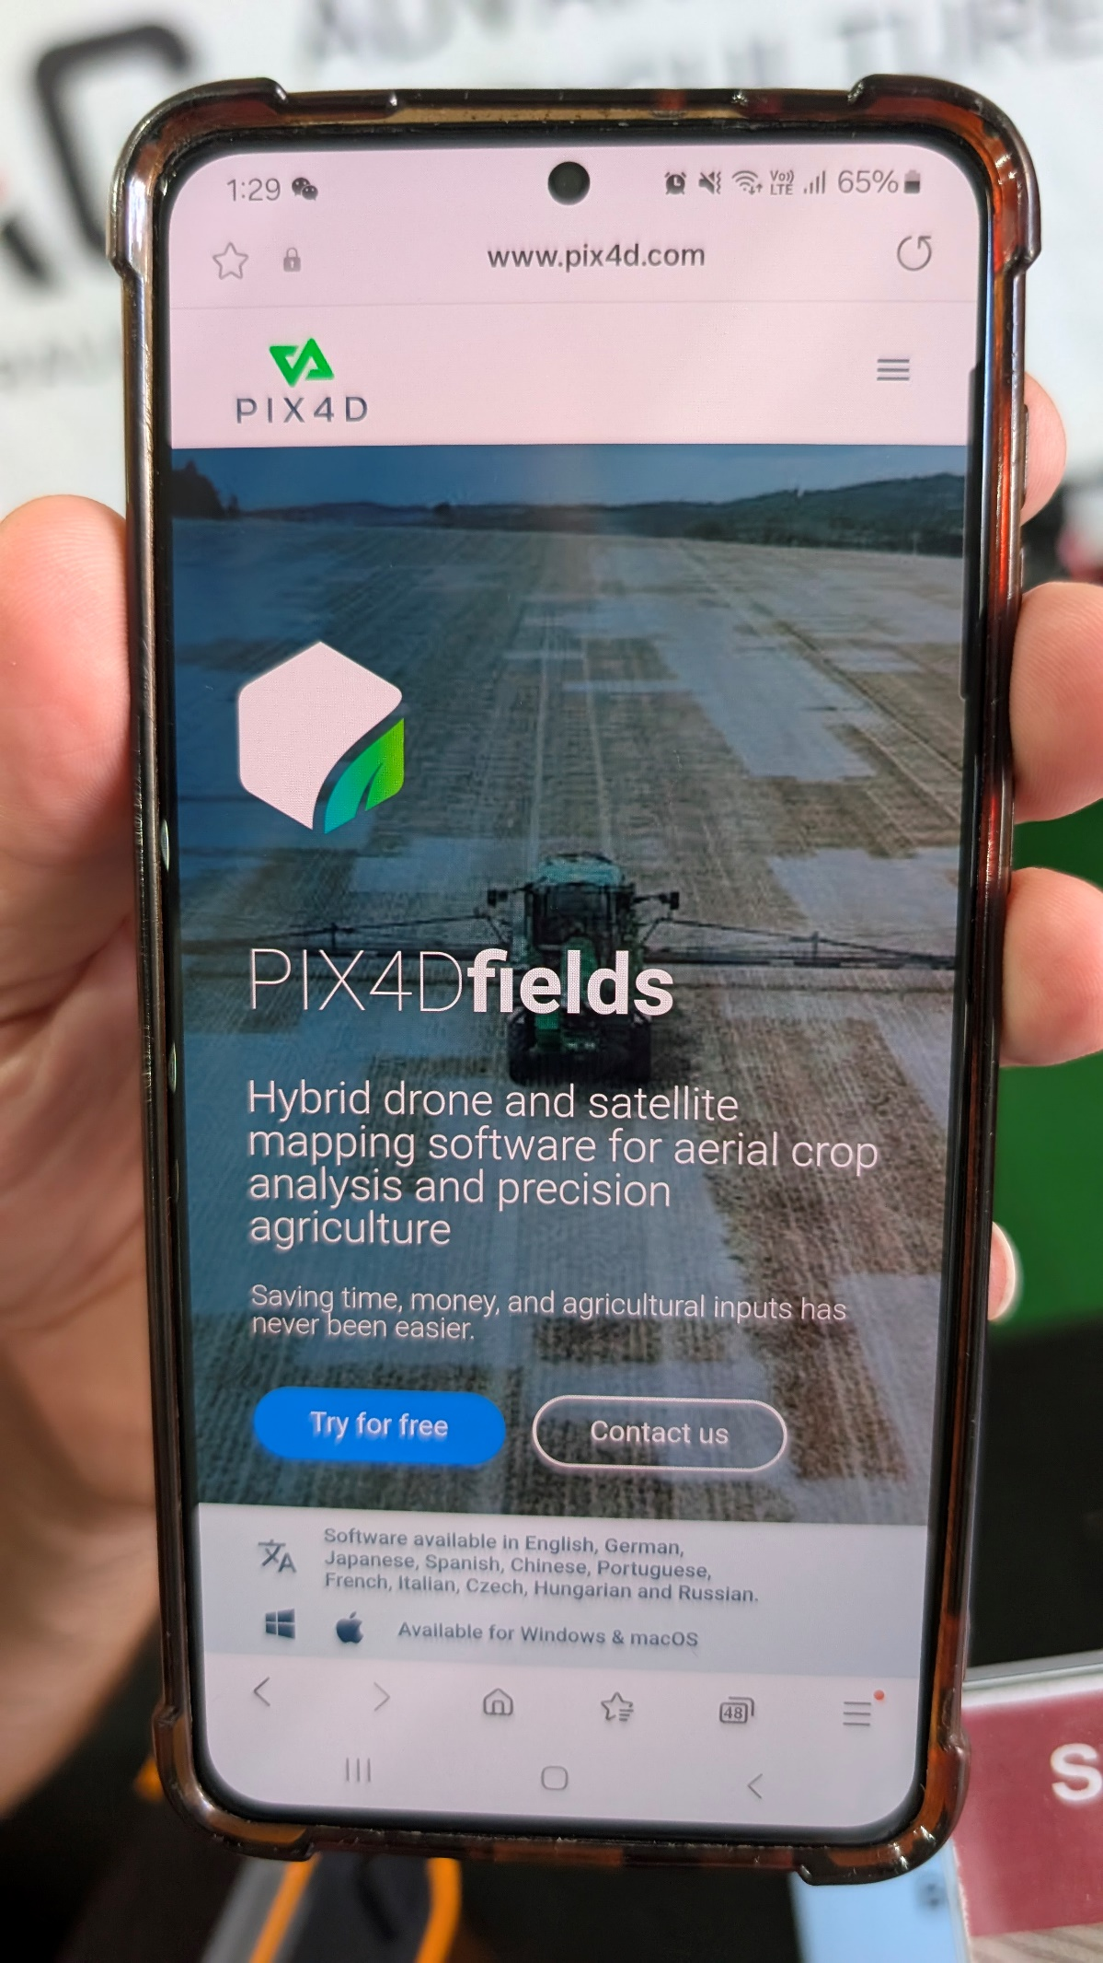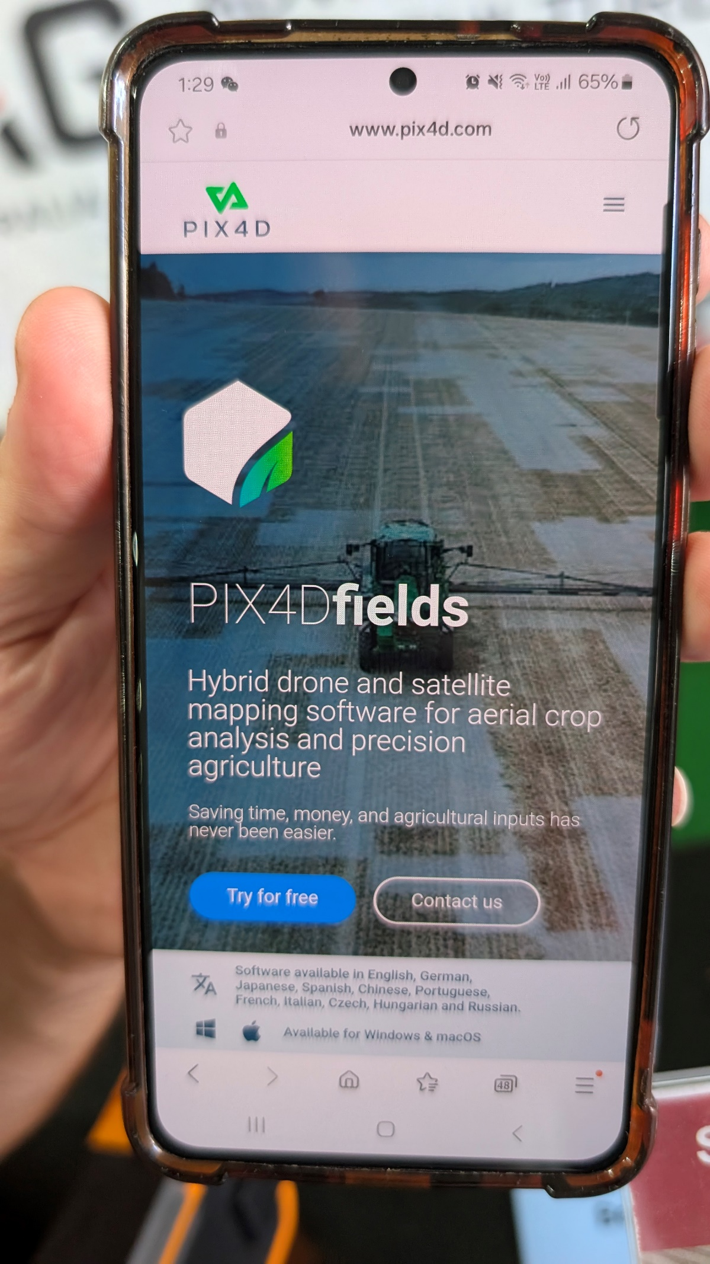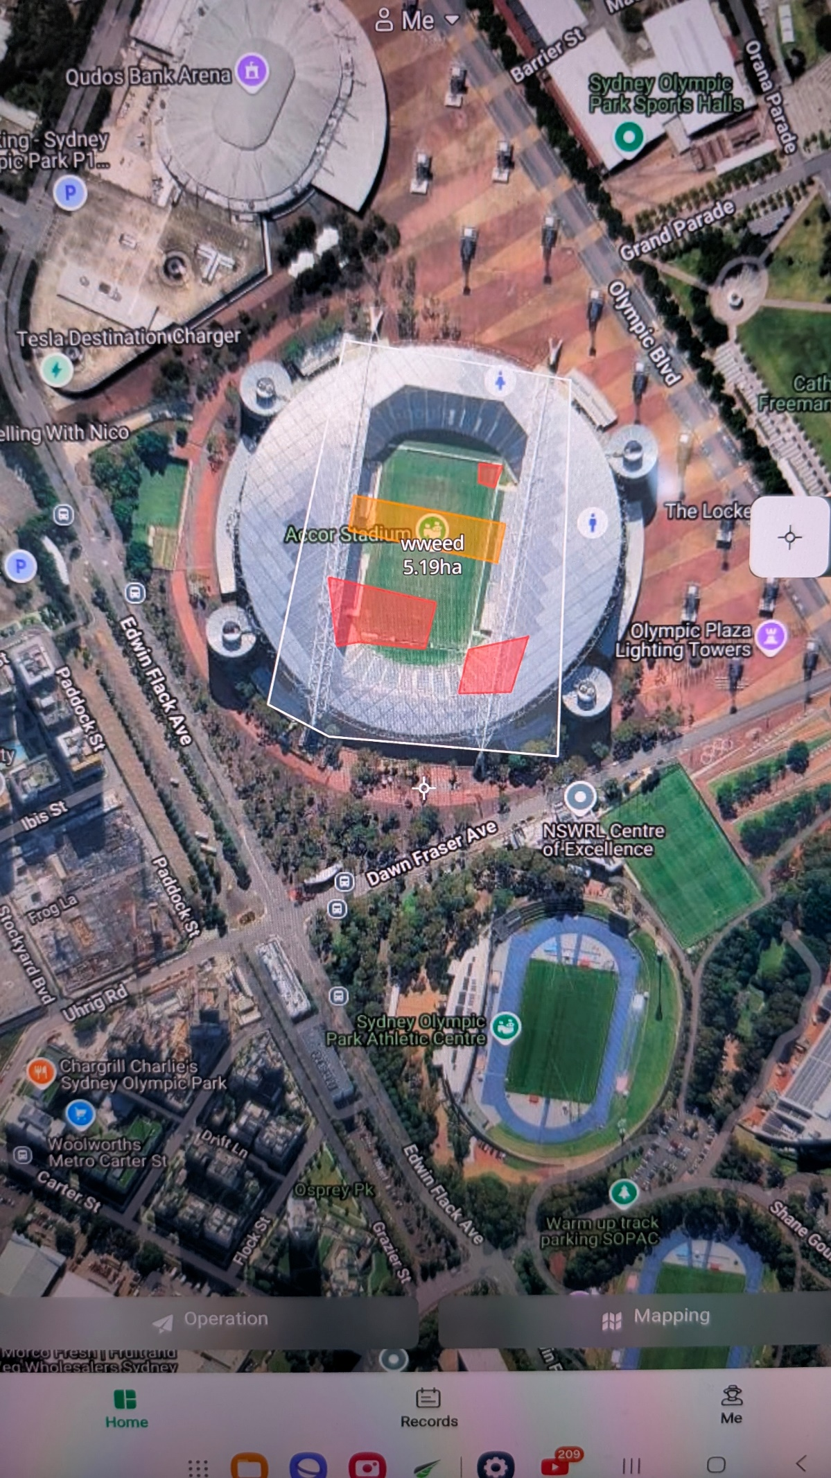
This is how the App looks… Red is no go area and orange is spray area

